Part A — Practice Programs (Hour 1)
Work these in your lab-NN/ folder before the project: do the first one or two in the lab; the
last (For Advanced Learners) is for home.
CO1,
CO2
Practical
Number CO/PO
1. Shape areas: an abstract Shape with abstract area(); subclasses Circle, Rectangle,
Triangle. Put a mix in a Shape[] and loop once to print each area and the running total,
tracking the largest — one loop handling every shape through polymorphism.

public abstract class Shape {
public abstract float Area();

public static class Circle extends Shape {
int r;

public Circle(int r) {
this.r = r;
}

@Override
public float Area() {
return (22.0f / 7) * r * r;
}
}
public static class Rectangle extends Shape {
int L, W;
public Rectangle(int L, int W) {
this.L = L;
this.W = W;
}
@Override
public float Area() {
return L * W;
}
}
public static class Triangle extends Shape {
int h=0;
float w=0;
public Triangle(int h, float w) {
this.h = h;
this.w = w;
}
@Override
public float Area() {
return 0.5f * h * w;
}
}
public static void main(String[] args) {
Shape[] shapes = {
new Rectangle(20, 30),
new Triangle(20, 10.0f),
new Circle(10),
};
float total = 0;
float largest = 0;
for (Shape s : shapes) {
float area = s.Area();
System.out.println("Area = " + area);
total += area;
if (area > largest) {
largest = area;
}
}
System.out.println("Total Area = " + total);
System.out.println("Largest Area = " + largest);
}
}
OUTPUT:
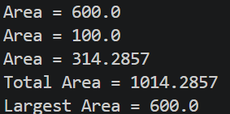

2. Payroll: an abstract Employee with abstract monthlySalary(); FullTime (fixed), PartTime
(hours × rate) and Intern (stipend), each calling super for the shared name/id. Loop a
mixed array to print each salary and the total; use instanceof to add a note only for
interns.

import java.util.Scanner;
public interface Employee
{
public int monthlySalary();
public static class Fulltime implements Employee
{
int Salary=20000;
String Id,name;
Fulltime(String Id,String name)
{
this.Id=Id;
this.name=name;
}
@Override
public int monthlySalary()
{
return Salary;
}
}
public static class Parttime implements Employee
{
String name,Id;
int time=0;
int rate=0;
int Salary=0;

Parttime(int time,int rate)
{
this.time=time;
this.rate=rate;
}

@Override
public int monthlySalary()
{
Salary=time*rate;

return Salary;
}
}

public static class Intern implements Employee
{
int Salary=0;
int type=0;
String name,Id;

Intern(int type,String name,String Id)
{
this.type=type;
this.name=name;
this.Id=Id;

}

@Override
public int monthlySalary()
{
if(type==1)
{
Salary=50000;
}
else if(type==2)
{
Salary=40000;
}
else if(type==3)
{
Salary=20000;
}
else
{
Salary=0;
}
return Salary;
}
}

public static void main(String[] args)
{
Employee[] employe={new Fulltime("25DCE110", "Kanan"),new Intern(3,"kannn","25dce110"),new Parttime(200, 2500)};
int salary;
int total=0;
for(Employee p : employe)
{
salary=p.monthlySalary();
System.out.println("The salary of employee is: "+salary);
total=total+salary;

if(p instanceof Intern) { System.out.println("Note: This employee is an Intern."); }

}
System.out.println("The total salary of all Employees is : "+total);
}
}
OUTPUT:
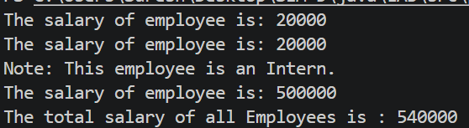

Key Questions / Analysis / Interpretation:
1. What is the difference between an abstract class and a concrete class?
An abstract class cannot be instantiated directly and may contain abstract methods. A concrete class can be instantiated and must implement any inherited abstract methods.
2. What is dynamic method dispatch (run-time polymorphism)?
Dynamic method dispatch occurs when Java selects an overridden method at runtime based on the actual object type. In MiniBank, an Account reference can call the appropriate interestRate() implementation for different account types.
3. What does the super keyword do in a subclass constructor?
The super() call invokes the parent class constructor to initialize inherited fields and behaviour.

